

Year Four

Parents’ Leaflet

How to support your child

with Maths at home

**By the end of Year 4 your child should;**

* Read and write numbers to 10,000.
* Know the value of each numbers in a 4-digit number.
* Order a set of 4-digit numbers (up to 5)in increasing and decreasing order.
* Count in multiples of 2, 3, 4, 5, 6, 7, 8, 9, 10, 25, 50, 100 and 1000 from any given number.
* Round any number to the nearest 10 or 100.
* Order a set of numbers between 10 and -10 in increasing and decreasing size.
* Add and subtract numbers using formal written methods with up to 4-digits.
* Recall multiplication and division facts for tables up to 12 x 12.
* Multiply and divide HTU by U and show remainder when appropriate.
* Write equivalent fraction of a fraction given the denominator or numerator.
* Tell times to nearest minute.

**Ideas for games you can play around the house**

**Number game 3 C:\Users\i.cork\AppData\Local\Microsoft\Windows\Temporary Internet Files\Content.IE5\UO9RTETL\MC900348635[1].wmfC:\Users\i.cork\AppData\Local\Microsoft\Windows\Temporary Internet Files\Content.IE5\SO8UBMVP\MC900325934[1].wmf C:\Users\i.cork\AppData\Local\Microsoft\Windows\Temporary Internet Files\Content.IE5\UO9RTETL\MC900348635[1].wmf**

Use three dice.

If you have only one dice, roll it 3 times.

♦ Make three-digit numbers, e.g. if you roll 2, 4 and 6, you could make 246, 264, 426, 462, 624 and 642

♦ Ask your child to round the three-digit number to the nearest multiple of 10. Check whether it is correct, e.g.

76 to the nearest multiple of 10 is 80

134 to the nearest multiple of 10 is 130

(A number ending in a **5** always **rounds up**.)

♦ Roll again. This time round three-digit numbers to the

nearest 100

**Tables**

Practise all the 12x tables. Say them forwards and backwards.

Ask your child questions like:

What are five threes?

What is 36 divided by 6?

Seven times nine?

How many eights in 48?

**Measuring**

Use a tape measure that shows centimetres

♦ Take turns measuring lengths of different objects, e.g. the length of a sofa, the width of a table, the length of the bath, the height of a door

♦ Record the measurement in centimetres, or metres and centimetres if it is more than a metre, e.g. if the bath is 165 cm long, you could say it is 1m 65cm (or 1.65m)

♦ Write all the measurements in order

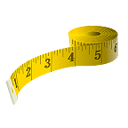

|  |  |
| --- | --- |
| **Number game 1**  You need about 20 counters or coins  ♦ Take turns. Roll two dice to make a two-digit number, e.g. if you roll a 4 and 1, this could be 41 or 14  ♦ Add these two numbers in your head. If you are right, you win a counter. Tell your partner how you worked out the sum  ♦ The first to get 10 counters wins  Now try subtracting the smaller number from the larger one. | **Number game 2**  ♦ Put some dominoes face down  ♦ Shuffle them  ♦ Each choose a domino  ♦ Multiply the two numbers on your domino  ♦ Whoever has the biggest answer keeps the two dominoes  ♦ The winner is the person with the most dominoes when they have all been used C:\Users\i.cork\AppData\Local\Microsoft\Windows\Temporary Internet Files\Content.IE5\IB5YLEDX\MC900384320[1].wmf |

**Looking around C:\Users\i.cork\AppData\Local\Microsoft\Windows\Temporary Internet Files\Content.IE5\0X2F6Y4O\MM900395755[1].gif**

Choose a room at home.

Challenge your child to spot 20 right angles in it. C:\Users\i.cork\AppData\Local\Microsoft\Windows\Temporary Internet Files\Content.IE5\10CZJOJE\MC900330154[1].wmf

**Sum it up**  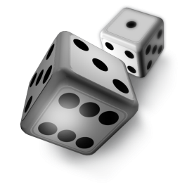

♦ Each player needs a dice

♦ Say: *Go!* Then each rolls a dice at the same time

♦ Add up all the numbers showing on your own dice, at the sides as well as at the top

♦ Whoever has the highest total scores 1 point.

♦ The first to get 10 points wins

**Out and about**

♦ Choose a three-digit car number, e.g. 569

♦ Make a subtraction from this, e.g. 56 – 9

♦ Work it out in your head. Say the answer

♦ If you are right, score a point

♦ The first to get 10 points wins

**H569 TPK **

**Dicey tens** 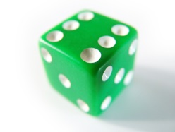

For this game you need a 1–100 square (a snakes and ladders board will do), 20 counters or coins, and a dice.

♦ Take turns

♦ Choose a two-digit number on the board e.g. 24

♦ Roll the dice. If you roll a 6, miss that turn

♦ Multiply the dice number by 10, e.g. if you roll a 4, it becomes 40

♦ Either add or subtract this number to or from your two-digit number on the board, e.g. 24 + 40 = 64

♦ If you are right, put a coin on the answer

♦ The first to get 10 coins on the board wins

**Mugs**

**You need a 1 litre measuring jug and a selection of different mugs, cups or beakers.**

♦ Ask your child to fill a mug with water

♦ Pour the water carefully into the jug

♦ Read the measurement to the nearest 10 millilitres

♦ Write the measurement on a piece of paper

♦ Do this for each mug or cup

♦ Now ask your child to write all the measurements in order

C:\Users\i.cork\AppData\Local\Microsoft\Windows\Temporary Internet Files\Content.IE5\T1GKSICJ\MC900340144[1].wmfC:\Users\i.cork\AppData\Local\Microsoft\Windows\Temporary Internet Files\Content.IE5\AGC7S55U\MC900030283[1].wmfC:\Users\i.cork\AppData\Local\Microsoft\Windows\Temporary Internet Files\Content.IE5\CKJSX2CR\MC900366396[1].wmf

**All the sixes**

Time your child while he / she does one or more of these.

♦ Count in sixes to 60

♦ Count back in sixes from 60 to zero

♦ Start with 4. Count on in sixes to 70

♦ Start with 69. Count back in sixes to 3

Next week, try to beat the record.

6 12 18 24 30 36 42 48 54

**Left overs**

**♦ Take turns to choose a two-digit number less than 50.**

**♦ Write it down. Now count up to it in fours. What number is left over?**

**♦ The number left is the number of points you score,**

**e.g. Choose 27.**

**Count: *4, 8, 12, 16, 20, 24.***

**3 left over to get to 27.**

**So you score 3 points**

**♦ The first person to get 12 or more points wins**

**Now try the same game counting in threes, or in fives.**

**Can you spot which numbers will score you points?**

[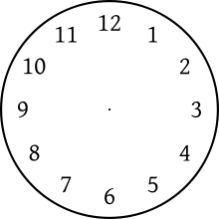](http://www.google.co.uk/url?sa=i&source=images&cd=&cad=rja&docid=EuPI-ildoRxTWM&tbnid=gnl_kpriSAkuAM:&ved=0CAgQjRwwAA&url=http://en.wikipedia.org/wiki/Clock_position&ei=NopMUrO5N-eG0AWK4IDQDQ&psig=AFQjCNEgKmKBES0-9t3R2iOoywCjOS2Y7Q&ust=1380834231035619)

**What time is it please?**

**Can you tell the time?**

Whenever possible, ask your child to tell you the time to the nearest 5 minutes. Use a clock with hands as well as a digital watch or clock.

Also ask:

♦ What time will it be one hour from now?

♦ What time was it one hour ago?

Time your child doing various tasks, e.g.

♦ getting ready for school;

♦ tidying a bedroom;

♦ saying the 5 times, 10 times or 2 times table…

Ask your child to guess in advance how long they think an activity will take. Can they beat their time when they repeat it?



Internet resources

Hit the Button

www.woodlands-junior.kent.sch.uk/maths

mathschamps.co.uk (Brick blaster)

www.topmarks.co.uk

www.mathszone.co.uk

www.bbc.co.uk/bitesize/ks2/maths

www.primaryinteractive.co.uk

Maths Magician (coolsciencelab.com/math_magician)

MyMiniMaths – This is a fantastic resource which gives children the opportunity to practise all aspects of the curriculum for their year group. Every day 8 questions are given and the answers are available.

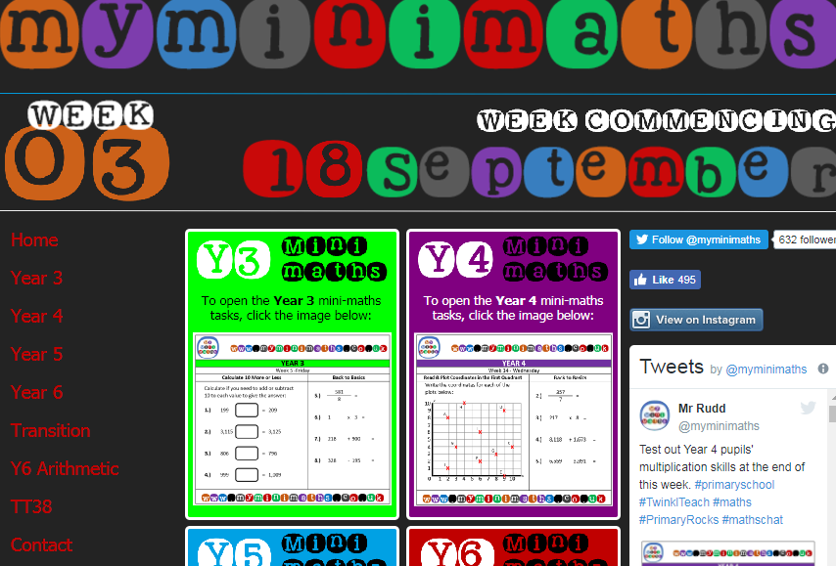

The Government has introduced a new National Curriculum for Maths in September 2014. Enclosed is the programme of study for this year group which states what children should be taught and know by the end of the year.

**Year 4 programme of study**

**By the end of the year children should be able to:**

**Number - number and place value**

* count in multiples of 6, 7, 9, 25 and 1,000
* find 1,000 more or less than a given number
* count backwards through 0 to include negative numbers
* recognise the place value of each digit in a four-digit number (1,000s, 100s, 10s, and 1s)
* order and compare numbers beyond 1,000
* identify, represent and estimate numbers using different representations
* round any number to the nearest 10, 100 or 1,000
* solve number and practical problems that involve all of the above and with increasingly large positive numbers
* read Roman numerals to 100 (I to C) and know that over time, the numeral system changed to include the concept of 0 and place value

**Number - calculations**

* add and subtract numbers with up to 4 digits using the formal written methods of columnar addition and subtraction where appropriate
* estimate and use inverse operations to check answers to a calculation
* solve addition and subtraction two-step problems in contexts, deciding which operations and methods to use and why
* recall multiplication and division facts for multiplication tables up to 12 × 12
* use place value, known and derived facts to multiply and divide mentally, including: multiplying by 0 and 1; dividing by 1; multiplying together 3 numbers
* recognise and use factor pairs and commutativity in mental calculations
* multiply two-digit and three-digit numbers by a one-digit number using formal written layout
* solve problems involving multiplying and adding, including using the distributive law to multiply two-digit numbers by 1 digit, integer scaling problems and harder correspondence problems such as n objects are connected to m objects

**Number - fractions (including decimals)**

* recognise and show, using diagrams, families of common equivalent fractions
* count up and down in hundredths; recognise that hundredths arise when dividing an object by 100 and dividing tenths by 10
* solve problems involving increasingly harder fractions to calculate quantities, and fractions to divide quantities, including non-unit fractions where the answer is a whole number
* add and subtract fractions with the same denominator
* recognise and write decimal equivalents of any number of tenths or hundreds
* recognise and write decimal equivalents to 1/4, 1/2, 3/4
* find the effect of dividing a one- or two-digit number by 10 and 100, identifying the value of the digits in the answer as ones, tenths and hundredths
* round decimals with 1 decimal place to the nearest whole number
* compare numbers with the same number of decimal places up to 2 decimal places
* solve simple measure and money problems involving fractions and decimals to 2 decimal places

**Measurement**

* convert between different units of measure [for example, kilometre to metre; hour to minute]
* measure and calculate the perimeter of a rectilinear figure (including squares) in centimetres and metres
* find the area of rectilinear shapes by counting squares
* estimate, compare and calculate different measures, including money in pounds and pence
* read, write and convert time between analogue and digital 12- and 24-hour clocks
* solve problems involving converting from hours to minutes, minutes to seconds, years to months, weeks to days

**Geometry - properties of shapes**

* compare and classify geometric shapes, including quadrilaterals and triangles, based on their properties and sizes
* identify acute and obtuse angles and compare and order angles up to 2 right angles by size
* identify lines of symmetry in 2-D shapes presented in different orientations
* complete a simple symmetric figure with respect to a specific line of symmetry

**Geometry - position and direction**

* describe positions on a 2-D grid as coordinates in the first quadrant
* describe movements between positions as translations of a given unit to the left/right and up/down
* plot specified points and draw sides to complete a given polygon

**Statistics**

* interpret and present discrete and continuous data using appropriate graphical methods, including bar charts and time graphs
* solve comparison, sum and difference problems using information presented in bar charts, pictograms, tables and other graphs